
FURTHER EDUCATION AND TRAINING CERTIFICATE: INFORMATION TECHNOLOGY: SYSTEMS DEVELOPMENT
ID 78965 LEVEL 4 – CREDITS 165
US ID:9015
SUMMATIVE ASSESSMENTS MEMORANDUM
APPLY KNOWLEDGE OF STATISTICS AND PROBABILITY TO CRITICALLY INTERROGATE AND EFFECTIVELY COMMUNICATE FINDINGS ON LIFE RELATED PROBLEMS

FULL NAME & SURNAME
ID NUMBER:
NAME OF ASSESSOR
DATE OF ASSESSMENT
VENUE

 | ACHIEVED | NOT ACHIEVED
KNOWLEDGE
SKILLS

Signature of learner | Signature of Assessor

ASSESSMENT PACK
Please complete the following sections (A and B) before commencing with this assessment. The moderator of this assessment will complete section C.
Section A Learner Information
Name:

Surname:

Date:

Contact telephone no:

Learnership agreement no:

Company: |  |  |  |  |  |  | Site:
ID

Section B Assessor Information
Name:

Surname:

Date:

Contact telephone no:

Assessor no:
Provider no: |  |  |  |  |  |  | Site:
ID

Section C Moderator Information
Name:

Surname:

Date:

Contact telephone no:

Moderator no:
Provider no: |  |  |  |  |  |  | Site:
ID

Results:

PART ONE

Assessors Guide

1. INSTRUCTIONS TO ASSESSOR

Introduction:

This assessment guide has been designed as a generic assessment guide and is intended for use by the accredited Training Providers.

Purpose of the assessment

The purpose of summative assessment against this unit standard is to:

♦Award credits to the NQF to learners who are able to start and run their businesses.

Learning assumptions

The following knowledge, skills, attitude and/or equivalent:
♦A knowledge, comprehension and application of language at NQF 03.

Assessment methods

The following assessment methods will be used for the summative assessments:
♦Written and/or/verbal questioning
♦Product sample and on site assessment

2. Assessment Process

General

- Use the assessment guide and your latest company policies and standard operating procedures to assess the evidence received from the learner.
- Use the section: Addition Comments/Questions to note down any further comments or questions on the evidence assessed.
- Use the model answers as a guideline to assess the learner’s answers to the assessment questionnaire.
- The learner can complete the assessment questionnaire orally. In this case, agree a date, time and venue.
- Provide the learner with a feedback within 10 working days of receiving the evidence.
Step 1 - Planning for the Assessment

Review this assessment guide to:

- Ensure that you understand all the requirements of the assessment in terms of evidence required to prove competence.
- Identify and prepare the learner for the assessment by:

  - Completing the Assessment Plan with the learner to discuss and agree the details regarding the assessment.
  - Completing the Assessment Preparation Checklist and getting the learner to sign.
- Ensure that you have familiarized yourself with the following:
  - The various patrolling functions and standard operating procedures within the company.

Step 2: Complete the Assessment

- Collect the evidence in accordance with the methods and evidence requirements specified.
- Mark each question as correct or incorrect in the “Office Use” column.
- Record the evidence on the assessment guide and indicate “Competent”, “Not Yet Competent” or “Not Assessed” for each assessment criterion. Note down any comments at the back of the assessment guide.
- Ask the learner additional questions, if necessary, to clarify points. Record these on the guide.
- All questions must be complete as per the criteria specified.
- Answers provided must be similar to the model answers.

Step 3 - After the Assessment

- Prepare the feedback by writing comprehensive, developmental feedback after each section on the Assignment Sheets. In addition to this, you are required to write a summary overall feedback on the Assessment Guide.
- Provide the feedback to the learner in a safe, undisturbed in nature.
- Ensure that your feedback is developmental and supportive in nature.
- Advise the learner on what action to follow in the event of a “Not Yet Competent” rating.
- Advise the learner on what action to take where he/she feels the need to appeal against your decision.
- Allow the learner time to provide you with feedback relevant to the process.
- Record the learner’s feedback in the guide and ensure that it is given to the person responsible for the quality assurance of assessment tools.
- Ensure that the learner co-signs the assessment guide to indicate agreement with the feedback.

3. Assessment documentation required:

Step 1: Planning for the Assessment

♦Assessment Plan
♦Assessment Preparation Checklist
♦Assessment Policy (including Appeals)
♦Evidence Matrix
♦Assessment Instruments

Step 2: Conducting the Assessment
♦Assessor Guide
♦Learner’s workbook
♦Summative assessment pack

Step 3: After the Assessment

♦Assessment Comments
♦Feedback Report

4. Specific Instructions

Please note that Part 3 Assessment Instruments are not included in this guide and are to be included by the assessor on an individual basis.

The actual summative assessments need to be completed and signed off by both learner and assessor. The assessor will take control of the completed assessment instruments and will file them under the tab for Assessment Evidence.

The completed assessment pack will be kept in safekeeping at the training provider for three months after endorsement by and will then be returned to the learner.

Guidelines where an appeal is lodged

- The normal appeal procedure prescribed by FPMSETA and described by the provider’s Quality Management System will be followed.

PART TWO

Assessment Planning

ASSESSMENT PLAN
ASSESSMENT DETAILS
Date of Assessment |  |  |  | Option 1 | Option 2 |  |  |  | Option 3 | Option 4
TIME OF ASSESSMENT
Start: |  |  |  |  |  | End:
VENUE |  |  |  |  |  | Contact  person
LANGUAGE MEDIUM
METHOD OF
METHOD OF ASSESSMENT (please tick off the one to be used)
OBSERVATION |  |  | ORAL |  |  |  |  | WRITTEN
Simulation |  |  | Knowledge test |  |  |  |  | Knowledge test
Product |  |  | Interview

PRE-ASSESSMENT MEETING CHECKLIST
ACTION | YES/NO | COMMENTS
Set learner at ease; be friendly, polite and professional.
Explain to the learner and agree on the
following issues.

- The unit standard that will be assessed
- Date, time, venue and process to be followed during the assessment.
- Summative assessment tools to be used for the assessment.
- The assessment plan
- Purpose of assessment
Explain to the learner and agree on the
role of all involved during the assessment
process.
Identify possible barriers and or disabilities
of the learner.
Explain the meaning and application of
RPL.
Explain, discuss and provide one complete
set of the Appeals process documentation.
Explain to the learner when final results
will be available and how feedback will be
provided.
Discuss previous assessment results if
applicable.

I, ______________________________ (initials and surname of learner), DECLARE THE FOLLOWING:

A copy of the unit standard(s) involved has been given to me prior to this meeting. I know I will beassessed against the criteria, which have been set to the applicable unit standards. The criteria have been discussed with me, and the procedures and purpose of the assessment has been clearly explained to me.

I am well aware of the venue, date and time that I will be assessed. I consider the period of time given to me to prepare myself for the assessment to be fair.

I understand clearly that I have the right to appeal against any decision made by the assessor during the assessment of the evidence provided by me and that I have free access to the appeals procedures attached to this assessment pack. I understand that I have the right to be accompanied by another person during all procedures, and that I have free access to the Training Division of SBV’S Health and Safety Procedures- filed at the offices.

Signature of learner | Date

PART THREE

Assessment Evidence

QUESTION 1
What do you think of when you hear the word statistics?

Asking a question gets the process started. It's important to ask a question carefully, with an understanding of the data you will use to find your answer. The question is most frequently derived from a problem situation and therefore can be seen as the core focus for the modelling of the data.
Collecting data to help answer the question is an important step in the process. You obtain data by measuring something, gathering relevant information pertaining to the problem situation or even through sampling which is another way to collect data. Experimentation is another.
Data must be organized, summarized, and represented properly in order to provide good answers to statistical questions. Also, the data you collect usually vary (i.e., they are not all the same), and you will need to account for the sources of this variation. The integrity of the source is of utmost importance to ensure for a accurate analysis.
After you analyze your data, you must interpret it in order to provide an answer -- or answers -- to the original question or problem situation.
You will become increasingly familiar with this process as you investigate different statistical problems.
From the recognition of trends to extracting patterns and extrapolating from data are higher-order problem-solving components of data interpretation and analysis. Therefore, before we can start to analyse data we need to understand how to collect the information, organise it effectively and then present it in an easy to understand format.

There are many forms of models which could be used to present and display information for analysis. Selecting the correct one could be critical so as to ensure that the applicable information can be analysed effectively.

QUESTION 2
The following table illustrates the products are sold in Vuyo’s Shebeen and the number of customers who purchased these products in a single day:
- Can you illustrate the above table as a Pie Chart

Product | # of Customers | Relative Frequency | Percentage
Simba Chips | 9 | 9/30 | 30%
Lemonade | 13 | 13/30 | 43%
Lion Larger | 6 | 6/30 | 20%
Cigarettes | 2 | 2/30 | 7%
Total | 30

Pie Charts
Pie charts are used to represent data from relative frequency distributions; i.e. they graphically represent data in percentages. This type of chart is simply a circle divided into portions whose area is equal to the relative frequency distribution. They are an excellent way to colourfully represent the data.
For example:
The following table illustrates the products are sold in Vuyo’s Shebeen and the number of customers who purchased these products in a single day:
Product | # of Customers | Relative Frequency | Percentage
Simba Chips | 9 | 9/30 | 30%
Lemonade | 13 | 13/30 | 43%
Lion Larger | 6 | 6/30 | 20%
Cigarettes | 2 | 2/30 | 7%
Total | 30

Figure 1.3.4.2 illustrates the above table as a Pie Chart
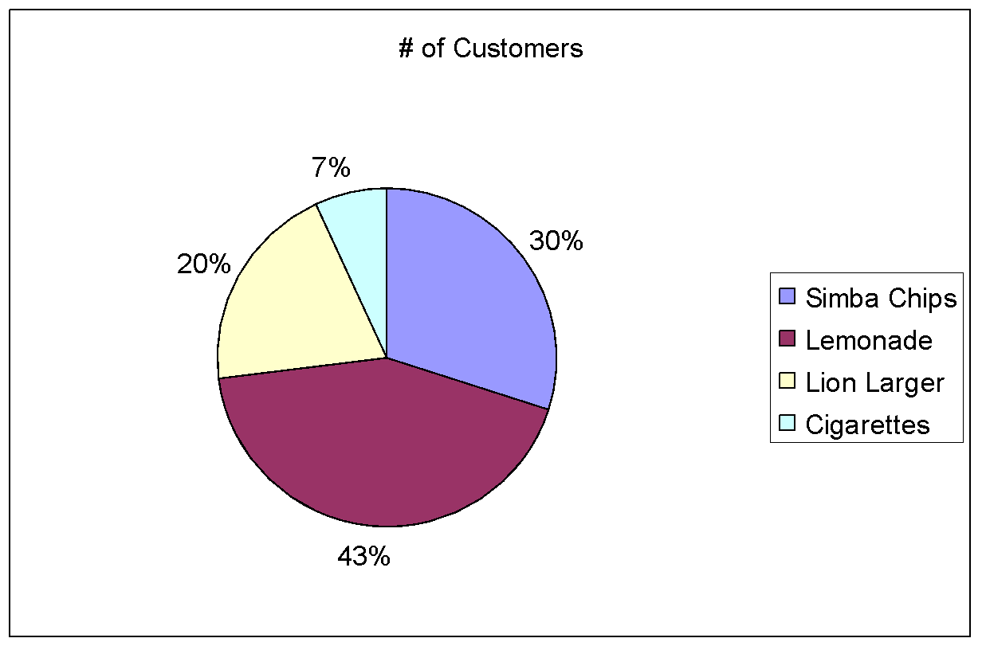
Once again, this gives a good visual representation of the data and it is easy to see that the largest percentage of sales was generated from lemonade during the period under review.

QUESTION 3
The table below represents Vuyo’s daily expenses for the period 1 January to 6 January 2004:
- Can you illustrate the above table as a bar chart.

Bar Charts
Bar charts are most useful when plotting individual data values next to each other. A histogram is in fact a special type of bar chart that plots frequencies rather than actual, individual data.
For example:
The table below represents Vuyo’s daily expenses for the period 1 January to 6 January 2004:
Date | Total Expenses (in Rands)
1st | 375
2nd | 514
3rd | 834
4th | 603
5th | 882
6th | 468
Represented as a bar chart, the above data looks like this:
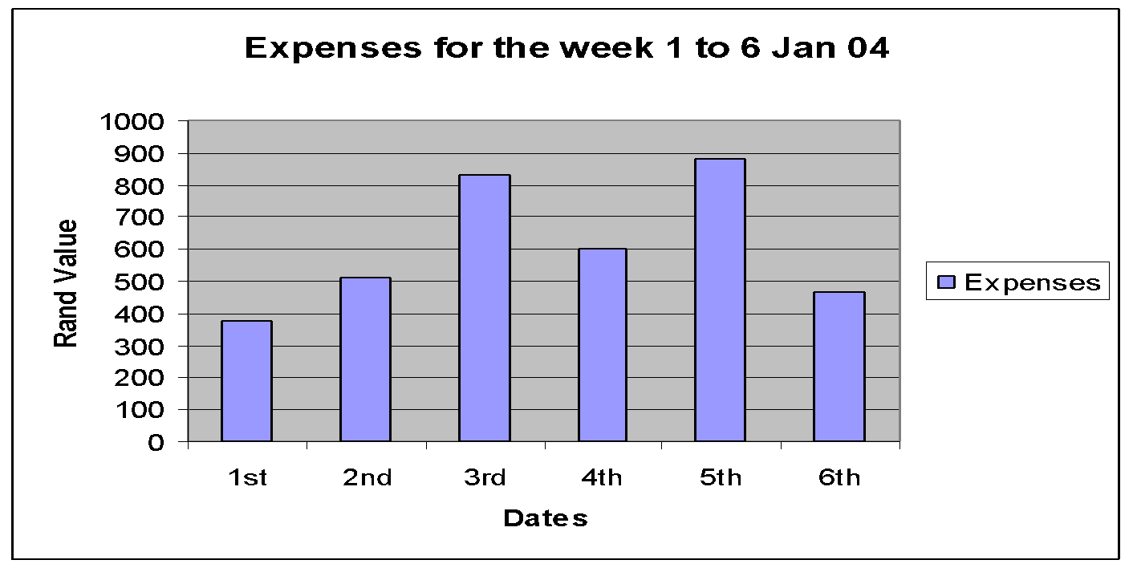
Vuyo can now see that his expenses were highest on the 3rd and 5th, so hopefully his income was equally higher on these two days!

QUESTION 4
- What is the probability of rolling a 3 on a die (plural, dice).
For example:
If Event A = rolling a total of 2, 3, 4, or 5 with 2 dice, we need to define the sample space for this experiment, which is shown in the table below:
{1, 1} | {2, 1} | {3, 1} | {4, 1} | {5, 1} | {6, 1}
{1, 2} | {2, 2} | {3, 2} | {4, 2} | {5, 2} | {6, 2}
{1, 3} | {2, 3} | {3, 3} | {4, 3} | {5, 3} | {6, 3}
{1, 4} | {2, 4} | {3, 4} | {4, 4} | {5, 4} | {6, 4}
{1, 5} | {2, 5} | {3, 5} | {4, 5} | {5, 5} | {6, 5}
{1,6} | {2, 6} | {3, 6} | {4, 6} | {5, 6} | {6, 6}
There are 36 total outcomes for this experiment, each with the same chance of occurring. The occurrences that correspond to Event A are underlined. There is a total of 10 occurrences, Therefore:
P[A] = 10
36
= 0.28
Thus, classical probability requires that you know the number of outcomes that pertain to a particular event. You also need to know the total number of outcomes of the sample space. As you will see with the next type of probability, knowing the total number of outcomes of the sample space is not always possible.

QUESTION 5
1. Look at the graph below, and then answer the questions that follow.
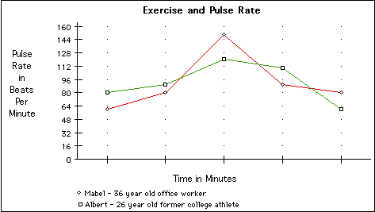
1.1. What was Mabel’s highest pulse rate?
1.2. What was Albert’s highest pulse rate?
1.3. What was Mabel’s lowest pulse rate?
1.4. What was Albert’s lowest pulse rate?
1.5. By referring to the graph, describe what happens to Albert’s heart rate during exercise.
2. Look at the graph below, and then answer the questions that follow.

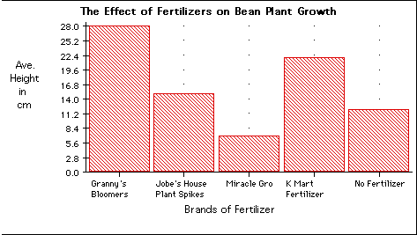
2.1. Which fertilizer was the most effective?
2.2. Which fertilizer was the least effective?
2.3. Calculate the average growth of all the fertilizers. Show your calculations below.
Learners must make observations and answer the two questions above accordingly.

